Case Study 2: Progressive Electricity Billing

1. Problem Statement
Develop a Python program to calculate an electricity bill based on the number of units consumed by a customer. The program should apply progressive billing rates for different consumption slabs, calculate the total electricity charges, and display the final bill amount.

2. Objectives
To calculate electricity charges based on units consumed.
To apply different rates for different consumption slabs.
To calculate the total electricity bill accurately.
To validate the units entered by the user.
To display the electricity consumption and total bill amount.

3. Assumptions
Electricity consumption is entered in units.
Units consumed cannot be negative.
The following progressive billing rates are assumed for this case study:
Units consumed | Rate per unit
First 100 units | ₹2
Next 100 units (101–200) | ₹3
Next 100 units (201–300) | ₹5
Above 300 units | ₹7
1. Each slab rate applies only to the units within that slab.
2.No additional taxes, fixed charges, or late fees are included.
3.The rates are assumed for academic purposes and may differ from actual electricity tariffs.

4. Algorithm
- Start the program.
- Input the number of electricity units consumed.
- Check whether the units are negative.
- If the units are negative, display an invalid input message.
- If units are up to 100, calculate the bill at ₹2 per unit.
- If units are between 101 and 200, charge ₹2 for the first 100 units and ₹3 for the remaining units.
- If units are between 201 and 300, charge ₹2 for the first 100 units, ₹3 for the next 100 units, and ₹5 for the remaining units.
- If units exceed 300, calculate charges using all four slabs.
- Display the units consumed and total electricity bill.
- Stop the program.

5. Flowchart

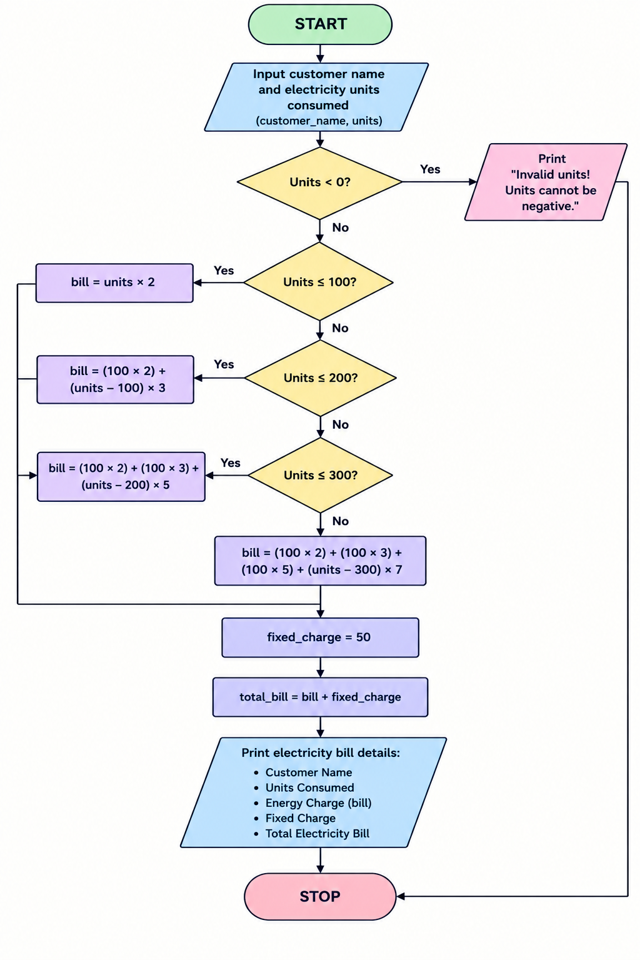

6. Pseudocode
START

INPUT units

IF units < 0 THEN
DISPLAY "Invalid input"

ELSE IF units <= 100 THEN
bill = units * 2

ELSE IF units <= 200 THEN
bill = 100 * 2 + (units - 100) * 3

ELSE IF units <= 300 THEN
bill = 100 * 2 + 100 * 3
+ (units - 200) * 5

ELSE
bill = 100 * 2 + 100 * 3
+ 100 * 5 + (units - 300) * 7

END IF

DISPLAY units and bill
END IF

STOP

7. Test Cases
Test case | Units consumed | Expected bill
1 | -10 | Invalid input
2 | 0 | ₹0
3 | 80 | ₹160
4 | 150 | ₹350
5 | 250 | ₹750
6 | 400 | ₹1,700

8. Output

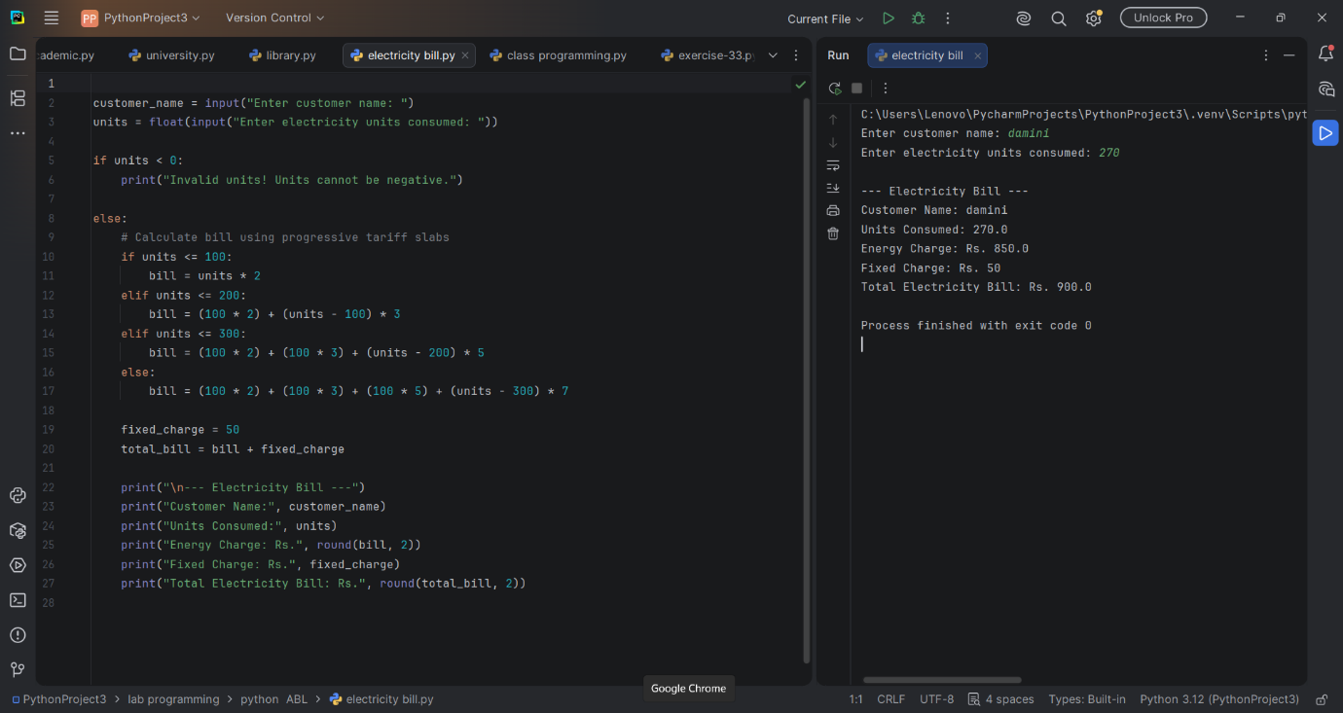

9. Conclusion
The Progressive Electricity Billing program calculates electricity charges based on the units consumed using different slab rates. It validates user input and applies the appropriate rate to each consumption slab. This case study demonstrates the use of Python conditional statements, arithmetic operations, and input validation to solve a real-world billing problem.

